WEEK 1 INTERNSHIP REPORT
Data Literacy and Analysis Techniques in E-Governance
Virtual Data Analysis Intern – E-Governance & Digital Services
Internship Organization | YuvaIntern
Intern | Aniruddha Patra
Internship Period | 6 October 2026 – 10 November 2026
Report | Week 1 Task
Submission Format | DOCX Report

Prepared for internship task submission

1. Executive Summary
Data literacy is increasingly important in e-governance because public institutions generate and use large volumes of information about citizens, transactions, service usage, performance and outcomes. A data-literate public-sector team can convert raw records into reliable evidence for planning, monitoring and service improvement. This report reviews the role of data in digital government, explains fundamental data-cleaning and statistical techniques, and illustrates their application through public-sector case studies.
Three examples are discussed: the United Kingdom Government Digital Service (GDS) Performance Platform, the UK Department for Work and Pensions' use of analytics to improve a digital service, and India's CoWIN vaccination platform. A small hypothetical dataset is also analysed to demonstrate practical data cleaning, descriptive statistics and a simple inferential comparison. The hypothetical analysis is explicitly illustrative and is not presented as official government data.

2. Introduction: The Role of Data in E-Governance
E-governance refers to the use of digital technologies, information systems and data to deliver public services, support administration, communicate with citizens and improve government decision-making. Data is central to this process because it provides evidence about demand, service usage, completion rates, waiting times, user satisfaction, costs and operational problems.
In a digital public service, data can be collected at multiple stages—for example, when a citizen searches for information, starts an online application, uploads documents, submits a form or completes a transaction. When these records are organised and analysed responsibly, administrators can identify bottlenecks and prioritise improvements. The UK Government Digital Service has described performance information as a way to help decision-makers focus on the information that matters, while its Performance Platform was designed to make service information more accessible and actionable.
Data-driven governance does not mean that every decision should be made by statistics alone. Data quality, privacy, accessibility, context and human judgement are equally important. Poorly defined indicators or incomplete records can lead to misleading conclusions. Therefore, data literacy includes the ability to understand where data comes from, assess its quality, select appropriate analytical methods, interpret results and communicate findings clearly.

2.1 Key Metrics for Digital Government
Metric | Meaning | Example Use
Users / sessions | Volume of people or visits interacting with a service | Measure demand
Completion rate | Percentage of started transactions completed | Identify friction
Drop-off rate | Percentage of users leaving before completion | Locate problem stages
Average completion time | Typical time required to finish a transaction | Monitor efficiency
User satisfaction | Reported satisfaction or feedback score | Assess user experience
Error / failure rate | Share of transactions affected by errors | Detect technical problems

3. Data Literacy in the Public Sector
Public-sector data literacy can be understood as the practical ability to read, evaluate, work with and communicate data in a responsible way. For an e-governance team, this includes understanding variables and units, checking data quality, recognising bias and missingness, selecting suitable statistics, interpreting uncertainty, and communicating results to both technical and non-technical stakeholders.
A useful data-literacy workflow is: Define the public-service question → identify relevant data → assess quality → clean and prepare the data → explore patterns → apply suitable statistical methods → interpret results in context → communicate findings → monitor the service after changes.

4. Methodological Framework

4.1 Data Cleaning
Data cleaning is the process of identifying and correcting or appropriately handling inaccurate, inconsistent, duplicated, missing or incorrectly formatted records. In e-governance, cleaning is especially important because records may be collected from different offices, databases or online forms.
Step | Activity | Practical purpose
1 | Check structure | Confirm variable names, data types, units and expected ranges.
2 | Remove duplicates | Identify repeated transaction or citizen-service records using suitable keys.
3 | Handle missing values | Investigate why values are missing; use justified imputation or retain missingness.
4 | Standardise formats | Unify dates, categories, spelling, codes and measurement units.
5 | Detect outliers | Use domain limits, IQR or z-scores to investigate unusual observations.
6 | Validate | Recheck totals, ranges and logical relationships after cleaning.

4.2 Descriptive Statistics
Descriptive statistics summarise the main characteristics of a dataset. Common measures include mean, median, minimum, maximum, range, variance and standard deviation. Percentages and rates are also important for public services because they make performance indicators easier to compare across periods.
For example, if the average completion time of an online service decreases while completion rate increases, this may indicate a positive change. However, analysts should also inspect the distribution and subgroup results because an average can hide differences between users or regions.

4.3 Inferential Methods
Inferential statistics use sample data to draw conclusions about a wider population while accounting for uncertainty. Depending on the question and data structure, methods can include confidence intervals, t-tests, chi-square tests, correlation and regression. The method must match the measurement scale, study design and assumptions.
For an illustrative before-versus-after service comparison, a paired t-test can be considered when the same units are measured at two time points and the differences are reasonably suitable for the test. The null hypothesis is that the mean paired difference is zero. A small p-value can provide evidence against that null hypothesis, but statistical significance should not be confused with practical importance.

5. Case Studies: Data Improving Digital Public Services

5.1 UK Government Digital Service – Performance Platform
The UK Government Digital Service developed the Performance Platform to make information about digital-service performance more accessible and actionable. The platform brought together service information so that managers could better understand how services were performing. Earlier work also explored measures such as task completion, time taken, drop-out points, comprehension and satisfaction. This illustrates how carefully selected indicators can turn raw usage data into operational evidence.
The important lesson for e-governance is that data is most useful when it is connected to a decision. A dashboard should not merely display large quantities of numbers; it should help service teams recognise problems, investigate causes and decide what to improve.

5.2 UK Department for Work and Pensions – Analytics for New Style JSA
The UK Department for Work and Pensions described how analytics was used to support the New Style Jobseeker's Allowance digital service. The team identified key performance indicators, enabled analytics with an appropriate cookie-consent mechanism, created dashboards and used quantitative data alongside user research. Analysis was used to assess changes, test hypotheses and inform further iterations. The case demonstrates the value of combining behavioural analytics with qualitative evidence rather than relying on a single metric.

5.3 India – CoWIN Vaccination Platform
CoWIN was developed as the digital backbone of India's COVID-19 vaccination programme. Government sources describe its use for registration, vaccination management, real-time tracking and monitoring of vaccine utilisation and wastage. The platform connected stakeholders and supported large-scale digital coordination. The case demonstrates how timely, structured data can support a public service operating at national scale.
For e-governance analysis, CoWIN also highlights the importance of scalability, interoperability and data quality. A digital platform can only support reliable decisions when information is captured consistently and made available to authorised users in a timely manner.

5.4 Case Study Comparison
Case | Data Focus | Analytical Use | Service Lesson
UK GDS Performance Platform | Usage and performance indicators | Monitoring trends and KPIs | Make performance data actionable
UK DWP New Style JSA | User behaviour + feedback | Analytics and hypothesis testing | Combine quantitative and qualitative evidence
India CoWIN | Registration, vaccination and operational data | Real-time monitoring and coordination | Scale, timeliness and data quality matter

6. Practical Analysis Using Hypothetical Data
To demonstrate the requested analysis methods without presenting private or unpublished information as official government data, this section uses a small hypothetical dataset representing a digital public-service portal. The observations are illustrative and were created only for this report.
Period | Users | Completed transactions | Avg. time (min) | Satisfaction (%)
Week 1 | 1000 | 720 | 9.4 | 68
Week 2 | 1100 | 836 | 8.7 | 71
Week 3 | 1200 | 984 | 7.9 | 77
Week 4 | 1250 | 1088 | 7.1 | 81
Cleaning checks for this illustrative dataset include verifying that users and completed transactions are numeric, that completed transactions do not exceed users, that time values are positive, and that satisfaction percentages remain within 0–100. No duplicate or missing records were intentionally included in this small example.
Metric | Mean | Median | Minimum | Maximum
Completion rate | 79.25 | 79.00 | 72.00 | 87.00
Satisfaction | 74.25 | 74.00 | 68.00 | 81.00
Average time (min) | 8.28 | 8.30 | 7.10 | 9.40
The descriptive results show an upward pattern in completion rate and satisfaction, while average completion time declines across the four hypothetical weeks. From Week 1 to Week 4, completion rate rises from 72% to 87% (15 percentage points), satisfaction rises from 68% to 81% (13 percentage points), and average completion time falls from 9.4 to 7.1 minutes (2.3 minutes). These patterns would be consistent with service improvement, but a four-week illustrative dataset alone cannot establish causation.
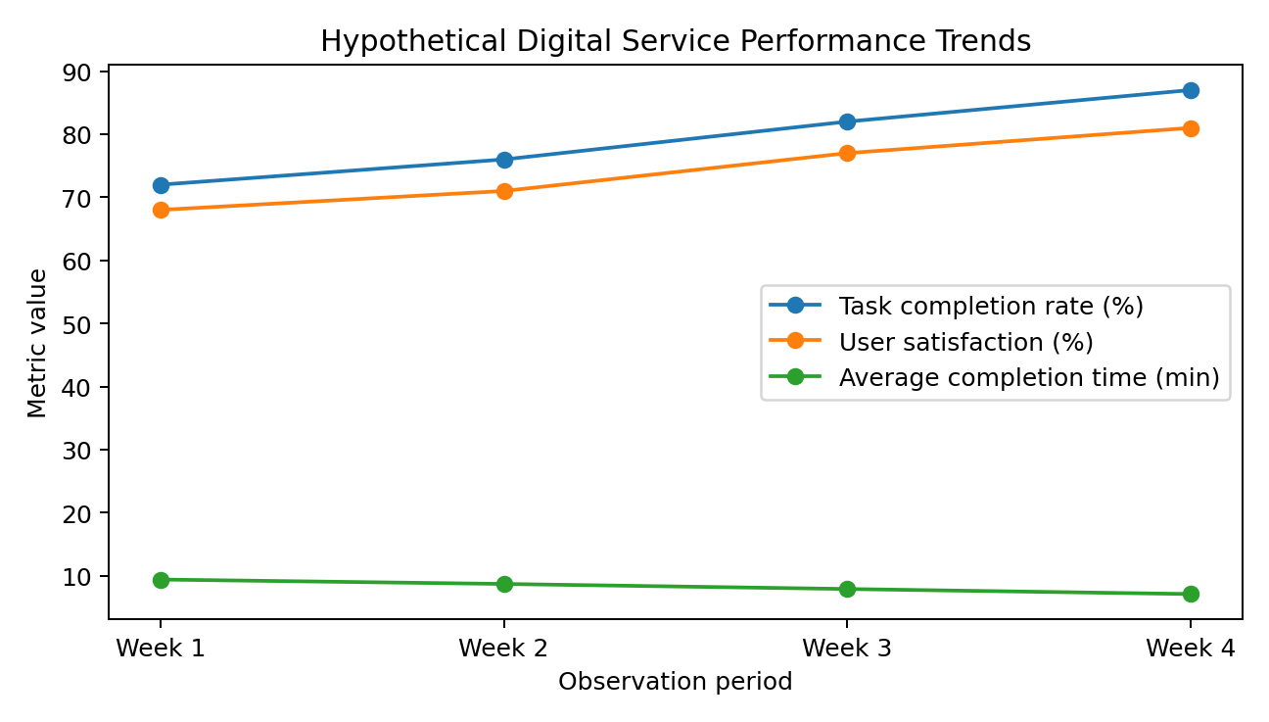
Figure 1. Trend illustration based on hypothetical data.

6.1 Example of an Inferential Question
A realistic evaluation could ask whether a redesigned online form reduces completion time. Suppose the same service units are measured before and after the redesign. A paired t-test could compare the mean within-unit difference. The analysis should report the mean difference, confidence interval and p-value, together with the sample size and assumptions. In a real government evaluation, analysts should also consider seasonality, user mix, simultaneous policy changes and other confounding factors.

7. Findings and Interpretation
- Reliable metrics make digital-service performance visible and support evidence-based decisions.
- Data cleaning is a necessary foundation; incorrect, duplicated or inconsistent records can distort downstream analysis.
- Descriptive statistics are useful for monitoring trends, while inferential methods can help assess whether observed differences are likely to be more than random variation.
- Public-sector case studies show that analytics is most effective when linked to clear service goals and user needs.
- Combining quantitative analytics with qualitative user research provides stronger context for service improvement.
- Hypothetical analysis can demonstrate a method, but it must not be presented as official or observed government data.

8. Recommendations for E-Governance Data Practice
- Define KPIs before collecting or analysing data so that each metric has a clear decision purpose.
- Maintain a documented data-cleaning and validation procedure, especially when combining datasets from different sources.
- Use dashboards that emphasise trends, exceptions and actionable indicators rather than unnecessary volume.
- Protect personal information through appropriate access controls, minimisation and responsible data handling.
- Use both quantitative metrics and citizen/user feedback when evaluating service changes.
- Document assumptions, limitations and methodology so that results remain reproducible and understandable.

9. Conclusion
Data literacy is a practical capability for modern e-governance. It enables public-sector teams to move from raw records to evidence that can improve service delivery. The report reviewed data cleaning, descriptive statistics and inferential methods and showed how these approaches can be applied to digital-government questions.
The UK and Indian case studies demonstrate that useful public-sector analytics is not simply about collecting more data. It depends on choosing meaningful indicators, maintaining data quality, understanding user behaviour, communicating results clearly and connecting findings to service decisions. The hypothetical analysis further illustrated how simple performance measures can reveal trends, while also showing why stronger evaluation methods are needed before claiming that a particular intervention caused an improvement.

10. Limitations
The practical dataset in this report is hypothetical and therefore cannot be used to make claims about the actual performance of a government service. The case studies are based on publicly available government and institutional sources. Real-world analysis would require access to the underlying data, a documented sampling or measurement process, privacy safeguards, and appropriate statistical testing.

11. Bibliography / Public Sources
- Government Digital Service (GDS). Building a performance platform for GOV.UK. GOV.UK/GDS Blog, 2012. https://gds.blog.gov.uk/2012/10/03/building-a-performance-platform-for-gov-uk/
- Government Digital Service (GDS). The Performance Platform: open for business. GOV.UK/GDS Blog, 2014. https://gds.blog.gov.uk/2014/04/07/the-performance-platform-open-for-business/
- Press Information Bureau, Government of India. CoWIN and digital public health information, 2026. https://www.pib.gov.in/
- Prime Minister of India. CoWIN Global Conclave: CoWIN as a digital public good, 2021. https://www.pmindia.gov.in/en/news_updates/pm-addresses-cowin-global-conclave-as-india-offers-cowin-platform-as-a-digital-public-good-to-the-world-to-combat-covid19/

12. Submission Note
This report was prepared specifically for the Week 1 internship task. The practical dataset and numerical illustration are explicitly hypothetical. Public case-study information is attributed to the listed sources.

